

29th November 2024

Dear Parent/Carer of children in Year 4,

As you may know, the Multiplication Tables Check (MTC) for year 4 children is happening between Monday 2nd June and Friday 13th June 2025. The leaflet ‘Information for parents – multiplication tables check’ will let you know more about what the MTC is.

**Why do the children need to take this test?**

All year 4 pupils in England will take the check. The Government made the check compulsory in 2022.

But why are times tables so important? Having rapid recall of times tables makes other areas of maths much easier. Every multiplication, division, long multiplication method and short division and long division method and working with fractions will require speed and instant recall of times tables while at primary school. At secondary school the needs become even greater.

Furthermore, having the times tables secure frees up their working memory for newer, more challenging tasks. So learning them now, in year 4, sets children up for a more successful maths career later in their school life.

**What can you do to help your child learn their times tables?**

Attached to this letter is your child’s heatmap (which can also be accessed by logging in to your child’s account> Stats> Fluency). It shows their current recall time for each of the times tables facts. The greener the fact, the quicker the response time. Any facts shown in red or orange are slower than 5 seconds, and should be practised. Obviously, we hope to achieve as many green facts as possible in preparation for the MTC!

Please, spend some time with your child looking at their heat map and identifying which tables they need to practise, and celebrating the ones they already know.



**Secure**

**Needs more practice**

**Getting there**

**How can you help them improve their recall times?**

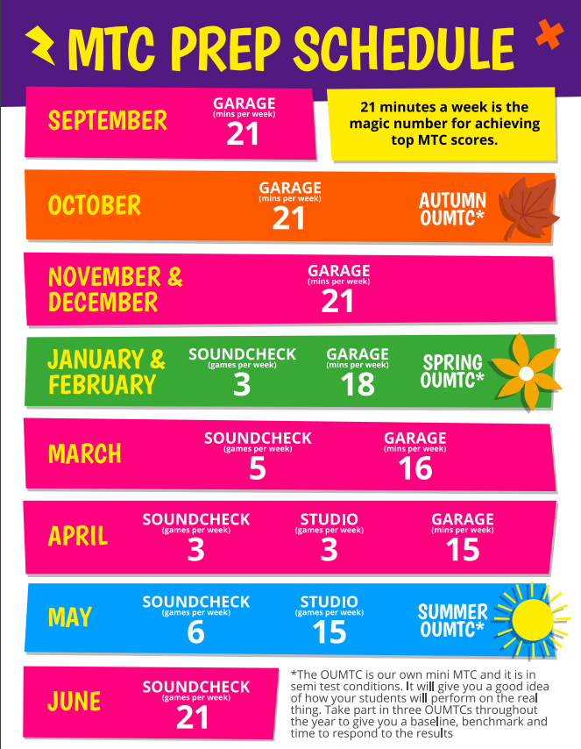

There are lots of ways to learn times tables, but here are a few suggestions to get you started:

* Play Times Tables Rocks Stars - Make sure they play daily in **Garage mode** on TTRS - The Garage game mode is very clever and will adjust the questions your child is asked, ensuring they are always working on the facts they need to improve. Also, give them a times tables square to use whilst they play. This way they can double-check facts they are not sure about. The TTRS MTC schedule (please see the image on the right which gives the recommended weekly practice times to support children preparing for their MTC).
* Sing times tables songs. There are hundreds available! Put them on in the car or any ‘free’ time where you have a few spare minutes.
* Chanting the old-fashioned way- rehearse the tables forwards and backwards, gradually increasing in speed.

**We would like to invite you to a special parent meeting on Monday 9th December 2024** after school. This will be a wonderful opportunity **to further discuss the MTC and** find out some key information for how to support your child. The meeting will be held from **3:30-4pm** in **3 Cedar**. Please come to the main entrance on Barford Road where a member of staff will be waiting to welcome you and direct you to the classroom.

We hope you can attend and look forward to seeing you at the session.

Yours sincerely,

Mrs L Hibell

KS2 Maths and TTRS Lead.